**Project Design Phase-I**

**Solution Architecture**

|  |  |
| --- | --- |
| Date | 15 October 2022 |
| Team ID | PNT2022TMID09796 |
| Project Name | Project – classification of arrhythmia by using deep learning with 2-d ECG spectral image representation |
| Maximum Marks | 4 Marks |

**Solution Architecture:**

Solution architecture is a complex process – with many sub-processes - technology solutions. Its goals are to:

* Smart arrhythmia of deep learning refer to the ECG equipment.
* Provide specifications according to which the solution is defined, managed, and delivered.
* The complete Bigdata architecture includes computing devices.
* It combines Software products to make more intelligent use of from ECG spectrum.
* **Example - Solution Architecture Diagram:**

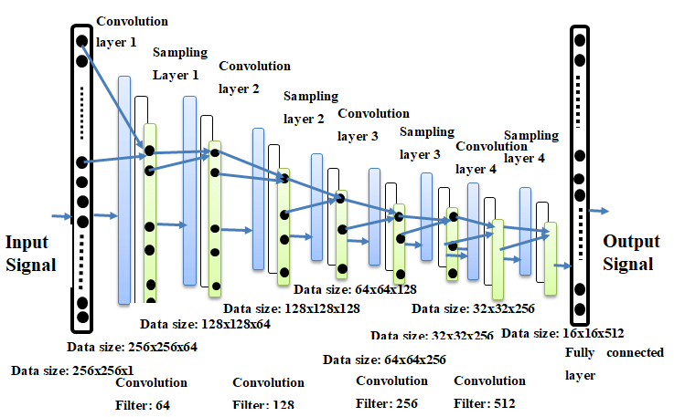

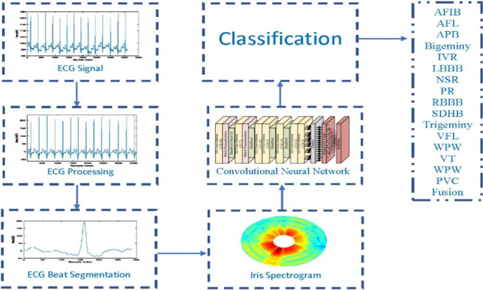

Figure 1: Architecture and data flow of the voice patient diary sample application

**Reference:** [**https://aws.amazon.com/blogs/industries/voice-applications-in-clinical-research-powered-by-ai-on-aws-part-1-architecture-and-design-considerations/**](https://aws.amazon.com/blogs/industries/voice-applications-in-clinical-research-powered-by-ai-on-aws-part-1-architecture-and-design-considerations/)